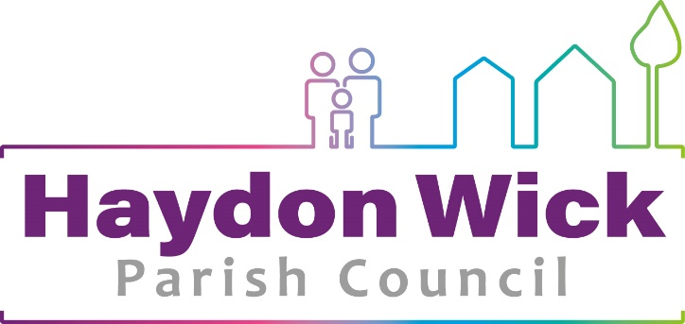

FLAG HOISTING POLICY

The Council will ordinarily fly three flag styles being the Union Flag, Flag of St George and a House Flag. The first two will be used for the dates as set for all UK government buildings in the relevant year. The House Flag will be flown as required on other dates. Flags will not be flown during severe weather warnings/conditions and planned maintenance.

Other flags to include Commonwealth Day, Armed Forces Day, will be flow during the designated day(s) or over the full weekend Friday to Monday of which this falls on.
- Flags will be flown from 8.00am to sunset
- The Union Flag and Flag of St George flown on days below
- Half-mast means the flag is flown two thirds of the way up the flagpole
- On Remembrance Day the flag is flown at full mast
- Union Flag to flown correct way up with the wider white diagonal stripe above the red diagonal strip nearest to the flagpole
- In the event of an extreme circumstance flags in solidarity with other countries will be flown at the discretion of the Chief Officer, Chairman & Vice Chairman and will be reported retrospectively at Full Council.
- The European Union flag is not currently classified as a national flag under the Town & Country (Control of Advertisements) Regulations 1992, will need advertisement consent to be flown
- Flags to be hoisted by authorised staff
- Union Flag will be flown on other occasions when authorised by Parliament
- Flags may only be flown at half-mast as advised by the Queen or the Department for Digital, Culture, Media and Sport or;
  - On the death/funeral of a serving member of the Armed Services from the Parish/Borough
- Armed Forces Day Flag on and before 26th June in accordance with advice from the Chief of the Defence Staff (CDS)
- European Nation Flags on their National Days following any request from relevant local community associations and/or groups of residents. Flags to be provided by the relevant community association/groups of residents
- Rainbow Flag on the Day against Homophobia. Flags to be provided by the relevant community association/groups of residents
- Disablement Flag on International Day of the Disabled in December. Flags to be provided by the relevant community association/groups of residents

Dates for flying the Union Flag on UK government buildings will be taken, each year from:

https://www.gov.uk/guidance/designated-days-for-union-flag-flying

Version Control
HWPC  Flag Hoisting Policy | Georgina Morgan-Denn  Chief Officer/Clerk to Council | Approved by Full Council  XXX | As and when amendments are required

