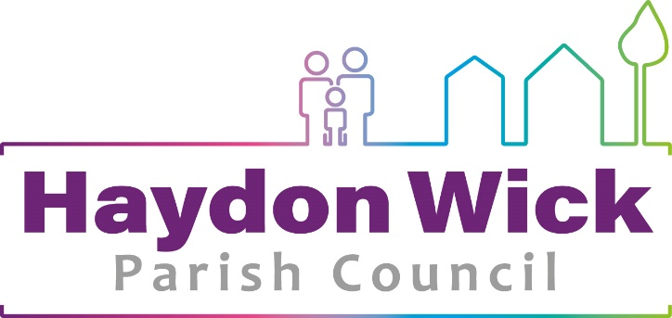

Haydon Wick Parish Council
Dog & Litter Bin Policy (Amended August 2022)

Introduction
Haydon Wick Parish Council are passionate about keeping the Parish tidy. To help achieve this goal there are a large amount of public litter and dog waste bins throughout the Parish that are emptied on a regular basis.
This policy sets out the procedures and requirements for the installation and maintenance of new bins, and the replacement of existing bins. It also defines protocol for responding to requests for bins.

Service
The Council has the responsibility for maintaining an acceptable level of cleanliness by installing, emptying and maintaining litter and dog waste bins throughout the Parish.

New Bin Requests
The installation of new bins should be sent to the Head of Parks & Open Spaces for consideration and reported at the following Parks & Open Spaces Committee meeting. Public litter and dog waste bins will only be located in areas where it can be demonstrated that there is a genuine need for one.
If the Head of Parks & Open Spaces deems the location to be unsuitable for reasons of safety, such as access to empty a bin, proximity to housing, or installation difficulties, it may be declined. Where possible, an alternative location will be considered in the locality.

If the bin request is approved, installation should take place within 20 working days.

Signage and Lining of Bins
Where necessary signage will be provided advising the public of the nearest litter and dog bin. In order to distinguish the bins maintained by the Council, all bins will be lined with coloured polythene liners.

Emptying of Dog/Waste Bins
The Head of Parks & Open Spaces in conjunction with the Parks & Open Spaces Team will determine procedures for emptying bins on a regular basis.

Maintenance of Bins
Over time, bins are subject to wear and tear, accidental or willful damage and will need to be either refurbished or replaced. The condition of the bins will be checked by the Parks & Open Spaces Team on a regular basis.

Approach to mixing of dog waste and general litter
Whilst the Council understands that dog waste may now be mixed with general waste for reasons of economic disposal the Council will still provide dedicated dog bins at strategic points in the Parish.

Preferred Style of Standard Bin Design
The two preferred bin styles are listed below.

Topsy Royale Bin by Glasdon Earth Anchors Dog Bin

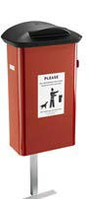
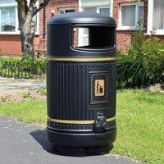

Version Control
HWPC  Bin Policy | Georgina Morgan-Denn  Chief Officer/Clerk to Council | Approved by Full Council  June 2019 | As and when amendments are required

