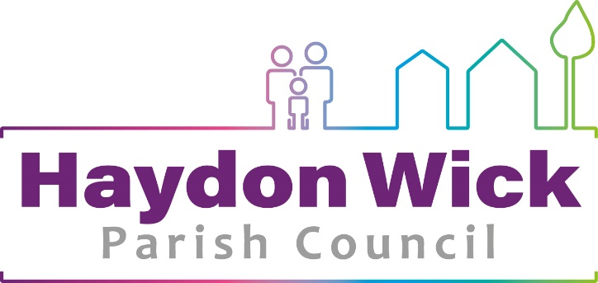

Complaints Procedure
Aims

- To provide a standard and formal procedure for considering complaints either made by complainants directly or which have been referred back to the Council from other bodies.
- To ensure that complainants feel satisfied that their grievance has been properly and fully considered.
- To make the process reasonable, accessible and transparent.
- At all times, the rules of natural justice will apply and all parties shall be treated fairly.
- All complaints shall be heard by the Council’s Finance & Policy Committee, which shall report its findings to Full Council.

Making a complaint

1. This policy document sets out procedures for dealing with any complaints about Haydon Wick Council’s administration and procedures. The conduct of Councillors is covered by the Parish Councils (Model Code of Conduct) (England) adopted by the Council on 24 July 2012. Complaints about a policy decision made by the Council will be referred back to the Council, or relevant Committee, as appropriate, for consideration.

2. If a complaint about the Council’s procedures or administration is notified verbally in person or via a specific set up ‘remote meeting’ to a Councillor or the Chief Officer, every effort should be made to satisfy the complaint directly with the complainant. If that fails, the complainant should be asked to put the complaint in writing to the Chief Officer at Haydon Wick Parish Council, The Council Offices, Thames Avenue, Haydon Wick, Swindon, SN25 1QQ or email clerk@haydonwick.gov.uk.

3. If the complainant does not wish to put the complaint to the Chief Officer, he or she should be advised to address it to the Chairman of the Council.

4. All complaints must contain the complainant's title, full name, address and signature and should be date stamped upon receipt within the office. The Chief Officer shall acknowledge receipt of the complaint within 14 days and advise the complainant that the matter will be considered at the next Finance & Policy Committee meeting. They will be given the opportunity to explain the complaint verbally.

5. On receipt of a written complaint, the Chief Officer, or if paragraph 3 refers, the Chairman and relevant Committee Chairman will seek to settle the complaint directly with the complainant. This will not be done without first notifying any person complained about and giving him/her an opportunity to comment. Every effort should be made to resolve the complaint at this stage.

- The Chief Officer will send a copy of the written complaint to the Chairman (or Vice Chairman if the complaint is against the Chairman) and to all members of the Finance & PolicyCommittee.

7. Where the Chief Officer or a Councillor receives a written complaint about the Chief Officer’s actions they shall refer the complaint to the Chairman. The Chief Officer will be formally advised of the matter and given an opportunity to comment.

8. The Chief Officer or Chairman shall report to the next Finance & Policy Committee meeting, any written complaint disposed of by direct action with the complainant.

9. The Chief Officer or Chairman will report any complaint that has not been resolved to the next meeting of the Finance & Policy Committee. The Chief Officer shall acknowledge the receipt of the written complaint and advise the complainant that the matter will be considered by the Finance & Policy Committee on the date provided.

10. The complainant shall be invited to attend the meeting and may bring a representative with them. If the Committee, after seeking the view of the complainant, consider it necessary, the matter may, by resolution of the Council be heard in private session.

11. At least seven (7) clear working days before the meeting, the complainant shall provide the Council with supporting documentation or evidence to substantiate the complaint against the Council. The complainant will also be provided with relevant documentation to which the Council will rely upon when the complaint is heard at the meeting.
Procedure of the Meeting
- The Finance & Policy Committee will decide whether the complaint warrants the exclusion of the public and press. The decision of the Committee however, will be made public at the conclusion of the meeting.
- The Chairman of the Finance & Policy Committee will facilitate the meeting, introduce everyone, and explain the procedure.
- The Complainant (or representative of the Complainant) will detail the complaint to the Committee.
- Members of the Finance & Policy Committee, if they wish, will ask questions of the Complainant relating to the complaint.
- The Chief Officer or Chairman of Council will present the Council’s position relating to the complaint (if necessary).
- Members of the Committee, if they wish, will ask questions of the Chief Officer/Chairman of Council.
- The Chief Officer/Chairman of Council and the Complainant will be offered the opportunity to make any final comments (in that order).
- The Committee will then consider the complaint in private.
- The Committee can re-open the meeting if clarification of points is needed from either party, but both parties must be invited back to the meeting.
- The Chairman of the Finance & Policy Committee may adjourn the meeting if wished in order that specialist advice may be sought.
- The Chairman of Finance & Policy Committee will ask all parties to re-join the meeting to inform them of the Committee’s recommendation to full Council. If a recommendation cannot be reached at the meeting, the Chairman will advise when the recommendation will be made and communicated to the Complainant.

After the Meeting

- Any recommendation on a complaint will be ratified and announced at the next meeting of the full Council.
- Within seven days of the Council accepting the recommendation of the Finance & Policy Committee, the Chief Officer will put the decision in writing to the complainant.

General
Any complaint that could result in disciplinary action being taken will be dealt with under the Council’s Grievance and/or Disciplinary procedures.
The Council will only consider making any liability payment or any other reasonable benefit to any person who has suffered as a result of its maladministration after taking appropriate advice from the Council’s Solicitors and Auditors (Local Government Act 2000 S92 – Payments in cases of Maladministration).
In the event of serial facetious, vexatious or malicious complaints from a member of the public the Council reserves the right not to act upon the complaints.

Local Councils as corporate bodies are not subject to the jurisdiction of the Local Government Ombudsman, and there are no provisions for another body to which complaints can be referred.

Version Control
HWPC  Complaints Procedure | Georgina Morgan-Denn  Chief Officer/Clerk to Council | Approved by Full Council  15 November 2016 FC 315.2.iv | As and when amendments are required
HWPC Complaints Procedure | Georgina Morgan-Denn  Chief Officer/ Clerk to Council and RFO | Approved by Full Council X,Y,Z | As and when amendments are required

